**Determine the top three expectations your client has for the website**

Clients are the most important source for a company. The expectations of clients should be met or exceeded to perceive high quality services. The first expectation of the clients are the website is clearly described about their company. The client is expect that the website is short and clearly described about their company, so that viewer can easy to understand about their company. Next, the second expectation of clients are having a good design for the website. A website with a good designed will make viewer more attractive with the website so that viewer will feel comfortable to stay with the website. Furthermore, The third expectation of clients are the web site present on mobile screen. Nowaday, people probably used smartphone to viewed site, so that the site that we designed must be present will on a variety of screen size.

**Determine the target audience**

Our target audience is mainly on those businessman and company who don't want do their accounts themselves and some of them don't have accounting knowledges. It is because some company will do their accounts themselves will make them company's accounts be more messy. Nowadays, accounting very important in business. It is because businessman or company must through monthly account or yearly account to know their business have profit or loss. In Malaysia, businessman or company need to pay taxes in every year.

**Locate three potential competitors (or similar websites)**

1. [http://www.alanyoonassociates.com/index.html](https://www.banana.ch/zh-hans)
2. http://www.yycadvisors.com/
3. [http://www.chengco.com.my/index.php](https://www.myob.com/au)

**For each competitor, note two strengths and two weaknesses**

AlanYoonAssociates is an accounting firm located in Kuala Lumpur. That accounting firm website URL is [http://www.alanyoonassociates.com/index.html](https://www.banana.ch/zh-hans) . Their website have some strengths also. Their navigation is easy to understand which web page are going. Other strengths of them is easy to know what business them doing. The weaknesses of their website is they using the font size is too small. Therefore, user will feel hard to read the website. Next, their website waste too much place of place. They can insert some picture or others element to make their website more attractive peoples.

In addition, the other potential competitors is YYC Advisors. The website URL of them is <http://www.yycadvisors.com/> . Their website’s strengths is they have added animation in their home page. The others YYC Advisors’s website strengths is their navigation easy to use for users. However, their website have some weaknesses also. Such as their website color is too monotonous and some of the part is too messy.

Furthermore, the other potential competitors is Cheng & Co. They located in Kuala Lumpur also. The Cheng & Co’s URL is [http://www.chengco.com.my/index.php](https://www.myob.com/au). The strengths of their website is the font size easy to see by everyone and their color design can attractive people during visit their website. Next, the strengths of their website is their navigation is easy control to everyone. Although their website is pretty good but have some weakness also. Such as their company logo and name too small and logo and name should put on the left side. Lastly, their website some content is disorder . specially in Home page.

**List the working title of each page on your web**

a) Kirk, Picard, & Janeway Home page

b) Kirk, Picard, & Janeway Services

c) Kirk, Picard, & Janeway Product

d) Kirk, Picard, & Janeway Contact

**Site Map**

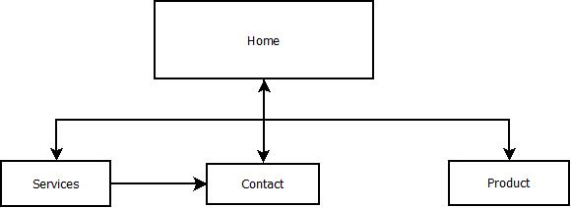

**Wireframe**

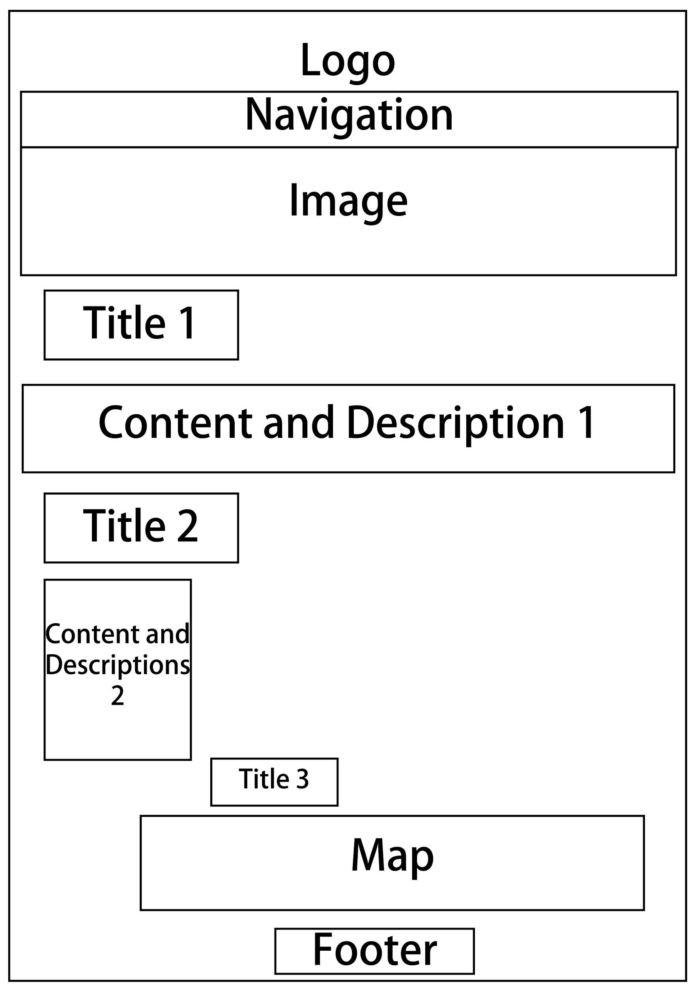

**Diagram 1: Home Page**

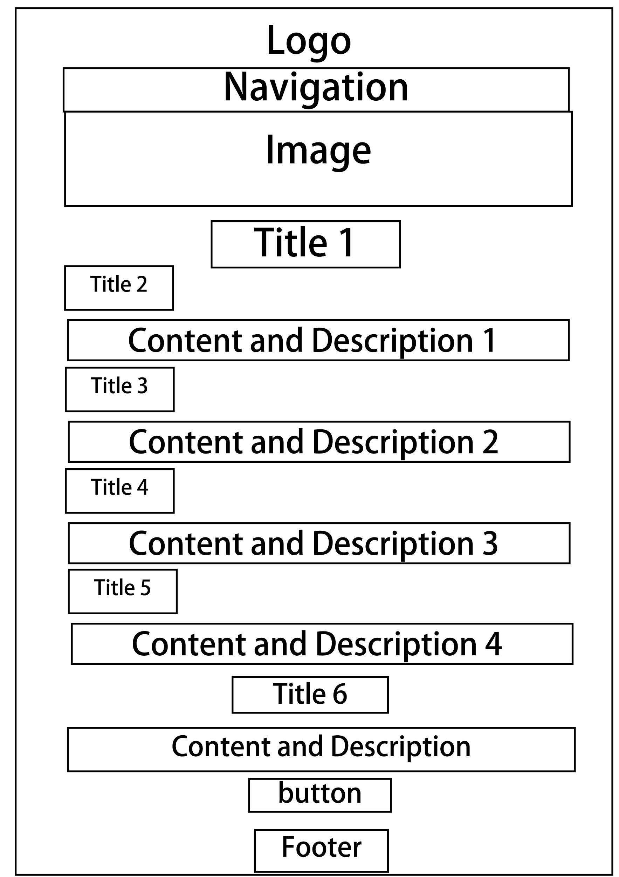

**Diagram 2: Services Page**

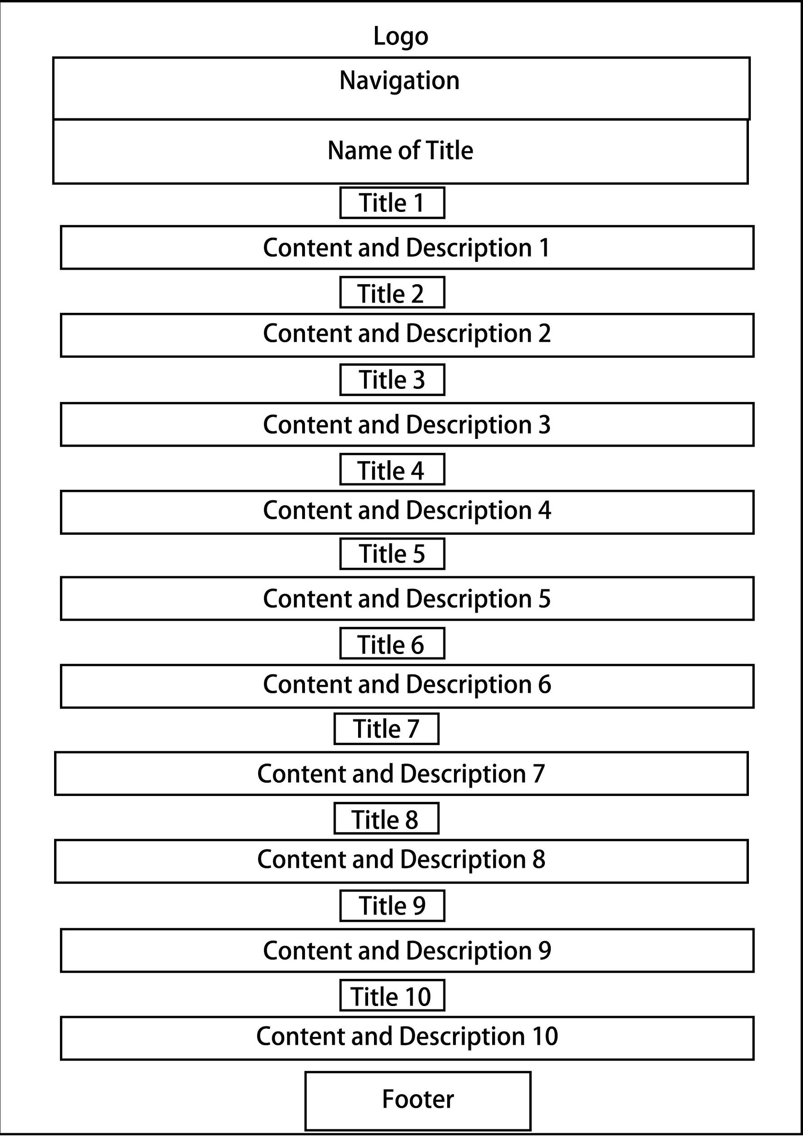

**Diagram 3: Product Page**

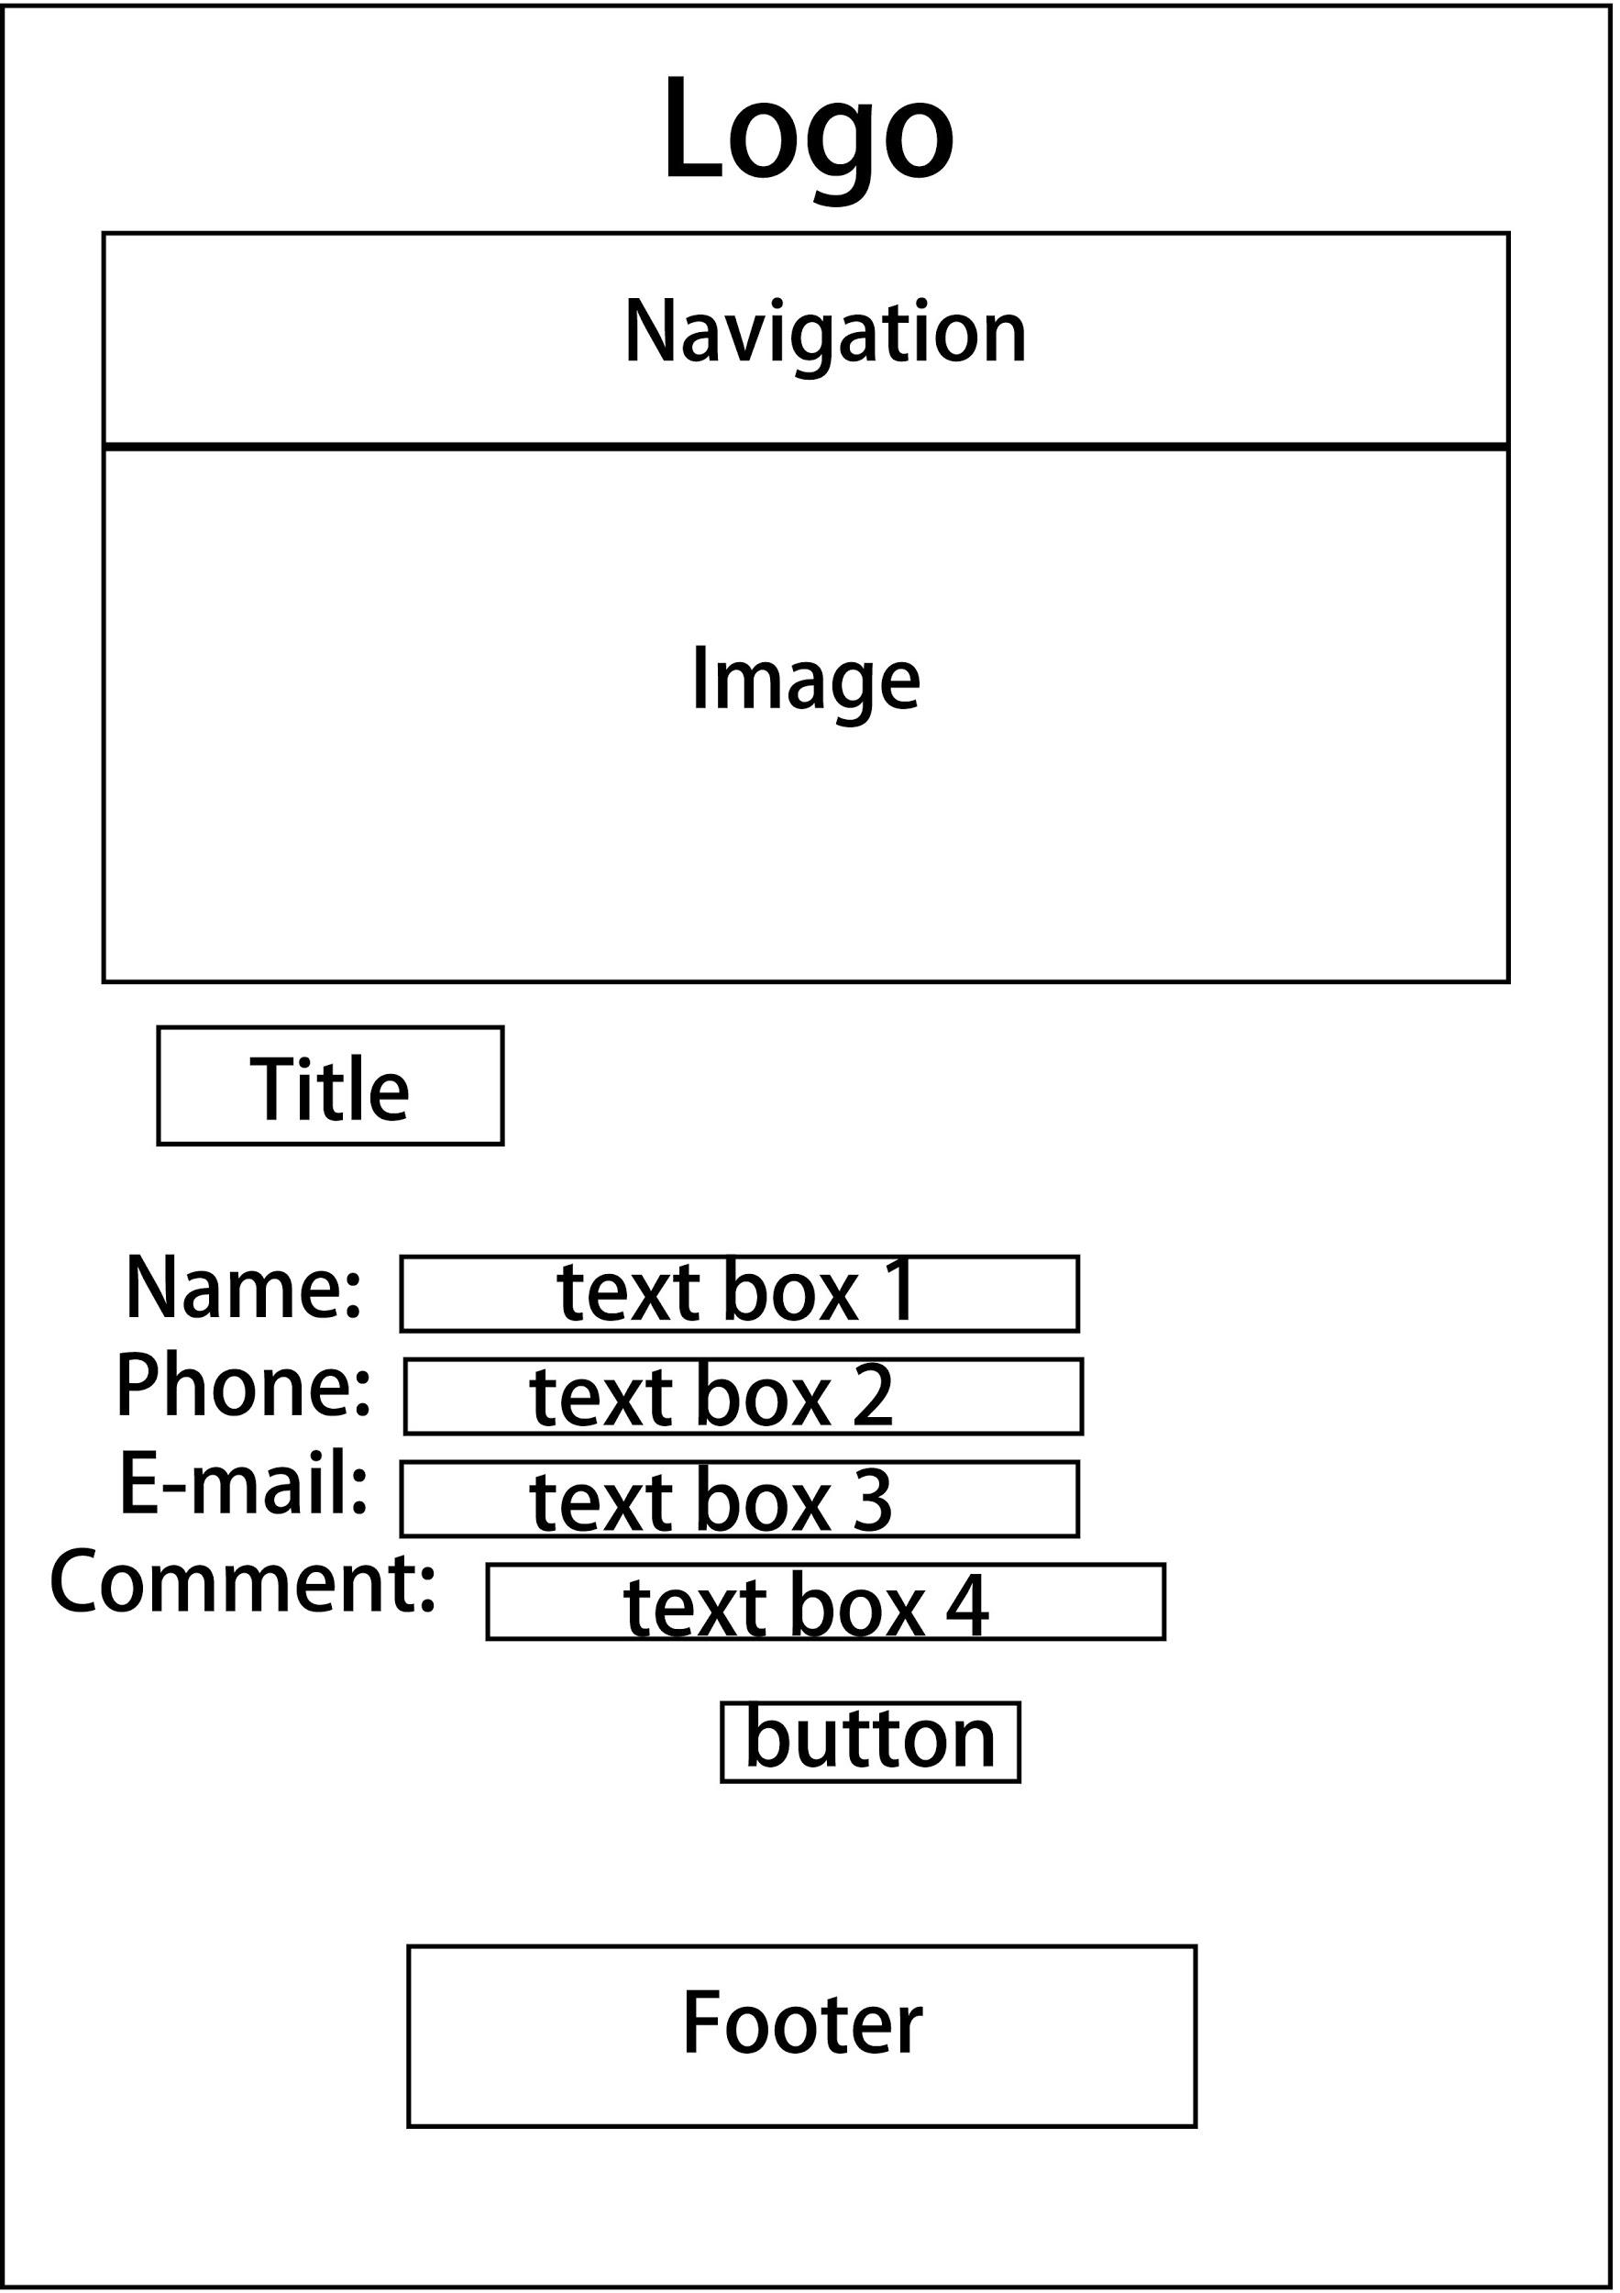

**Diagram 4: Contact Page**